CABIN FEVER: PROTOTYPE
By Esmeralda Conde Ruiz

VISUAL STORY

A Relaxed Performance
Saturday 12 June 12pm (EDT) - Sunday 13 June 12pm (EDT)
For questions please contact : cabinfever24hours@gmail.com

ABOUT THE PERFORMANCE
Performance Times
The performance runs for 24 hours but you can watch for as long as you like, 5 minutes to 5 hours - it is up to you! You can tune in more than once over the course of the performance to catch different moments or leave the performance playing on your laptop or phone whilst you go about your day/or night. You are not expected to watch the full 24 hours.

It will start at 12pm (EDT) on 12 June and will end at 12pm (EDT) on 13 June.

Registration
To register for this performance you can either email Clayton at clayton@spiderwebshow.ca or visit https://www.folda.ca/event/cabin-fever-prototype/ and click the pink register button (Pictured Below). You will then receive the link to view the performance.

A pictuer of the FOLDA website where you register:
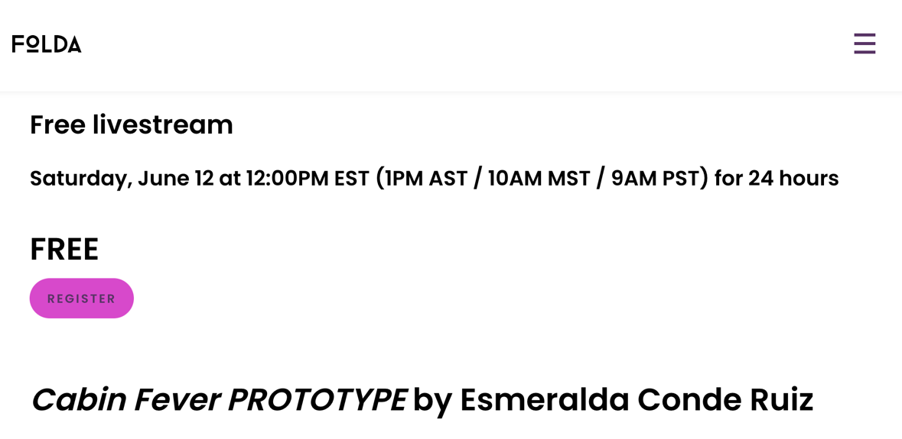

Environment
The performance is entirely online. Watch from the comfort of your own home from your laptop, desktop computer or phone. Music will feature so you may want to make sure you have your volume turned on.

WHAT HAPPENS?
How does it look?
If you tune in for the start of the performance at 12pm (EDT) you will see our opening title, which looks like this:
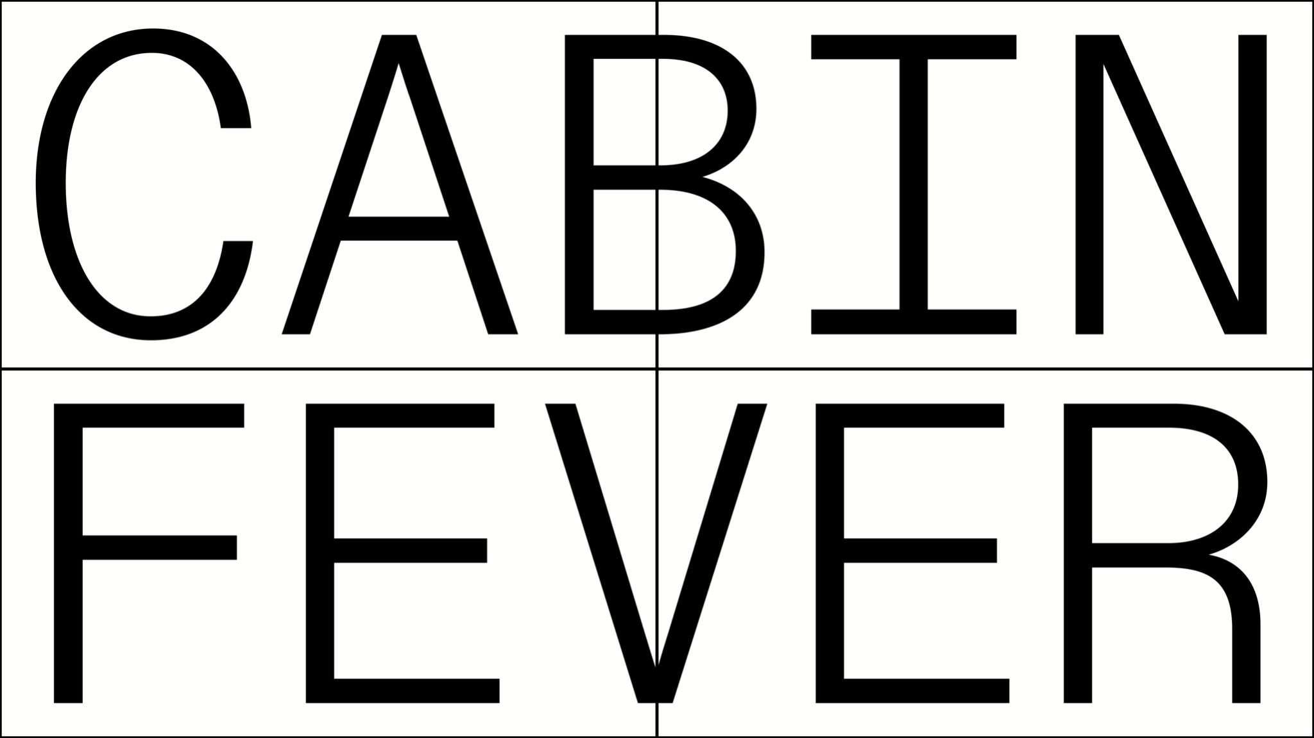

This will stay on the screen for a few moments and then each square will gradually change to almost black like this:
---->---->---->

You will then hear our first piece of music.

The music will last for 5 minutes.

After 5 minutes there will be 25 minutes of silence and then the music will play again.

There are 24 different pieces of music during the performance. Each piece of music is repeated twice - on the hour and every half hour.

When the music stops the squares on the screen will change, more will appear or disappear. Every 5 minutes the number of squares you see will change and sometimes they will also change colour.

Each 5 minutes will have one predominant colour. For example a ‘blue’ 5 minutes could look like this:

Each square will be a slight variation on each colour, sometimes darker, sometimes lighter. Each square will also move very slightly and may seem to tremble slowly or flicker and change.

This is how the entire 24 hours will look.

How does it sound?
Each hour you will hear the following pieces of music repeated twice. Once on the hour and once 30 minutes after the hour. Each piece of music lasts 5 minutes.

Hour 1: You hear a female voice singing the words ‘My son who is 7 was eating £1 coins like cereal. He had milk with them too’ in English. She is singing alone and the volume of her voice gets louder and quieter due to the internet connection. No one else is heard. Her voice is high and gentle. The melody is sad.

Hour 2: You hear a male voice leaving a phone voicemail message in Portugese saying: ‘One of the ways to eliminate the virus was to do the inverted position of yoga and this was much more effective than alcohol gel!’ Directly afterwards you hear a loud smoothie machine being used, crushing ice and making a smoothie. A small choir of mixed voices starts gently humming the machine’s pitch and imitating the machine’s sound. They occasionally create harmonies and sing with each other. Every singer has a different internet connection and microphone quality that's why some voices are louder and some are softer. The melody is calm and peaceful.

Hour 3: You hear 4 singers, 3 female and 1 male, singing in 3 different languages, English, German and Italian. They are singing in their mother language: ‘I had a dream, I was trying to talk to Mother Nature about the covid crisis. She was in the form of Gaia and eating peaches from a peach tree. She seemed indifferent to my asking to help out humanity. She nodded and said maybe with a coy smile.’ The melody is calm and peaceful and they create harmonies while singing together.

Hour 4: You hear a loud coffee machine. A single high female voice starts singing along with the coffee machine’s pitch, other female voices join her singing ‘ooohhh’. The single high female voice has a very weak internet connection which creates an interesting electronic effect on her voice which is featured a lot in this dream. Male voices join now too and a speaker starts speaking in Brazilian while the choir continues singing in the background. He says: ‘I was preparing garlic and oil pasta, with tomato sauce, grated vegetable cheese and lentil meatballs. All of this to the sound of a suspense / horror song played on a piano.’ He is speaking in a clear voice, later you hear him again more distorted as singers increase in volume. The music sounds mysterious and there is no silence.

Hour 5: You hear a wind chime making calm tones in the wind. A male speaker says in English: ‘There was a snow sculpture contest in the neighbourhood where I live. I was walking around admiring the snow sculptures, many of which were very good. Then a girl, who looked a little bit like my daughter used to look when she was little, started manically destroying snow sculptures. She knocked the head off a particularly beautiful horse sculpture.’ A small choir joins, this time not singing but making sounds (ttt, sss, shhhhh) and some singers play tones on water filled glasses. The speaker repeats his dream but is more and more distorted.

Hour 6: You hear two male voices singing the words ‘I often dream about breaking through the wall in our bathroom and discovering a second, fancier bathroom on the other side.’ in English. One of the voices is low, the other is high. They are singing loudly and are trying to sing in sync but can’t because of the delay of their connections. They still enjoy singing together and repeat the song over and over again. The melody is upbeat, as if they would have started singing in a pub.

Hour 7: You hear a female voice speaking in Spanish: ‘I was in my house and I randomly for some reason checked behind my drawer and there were a bunch of cockroaches like hundreds and they all scurried away’. A group of 5 female singers harmonises the word ‘cucarachas’(cockroaches), trying to be in rhythm and in sync with each other. The speaker sings some of the sentences alone, the singers repeat words, together, as close as possible. The melody is upbeat.

Hour 8: You hear a male bass voice singing ‘I was in my backyard, and I dreamt that I had to fight Clint Eastwood to death because if I didn't, he would kill me. And so we fought with swords and I eventually won’ in Spanish. There are long silences. He is singing alone until he says ‘Clint Eastwood’. A small choir of female singers repeat ‘Clint Eastwood’ after him trying to harmonise with each other. They sing in call and response with the lead singer & their voices come in and out due to the software switching off the loudest voice. The song is calm and soothing.

Hour 9: You hear a female voice speaking in American: ‘I was crawling through the ceiling to get to a party. Other people were crawling through the same space. I was wearing white silk trousers as I crawled. Someone who was crawling beside me asked me why I was wearing such expensive trousers to crawl through the ceiling. I said they had cost $900.’
She is singing alone and the volume of her voice gets louder and quieter due to the internet connection. No one else is heard. Her voice is high and gentle. The melody is sad. Her voice comes and goes. A mixed choir of voices starts gently singing ‘oohh’ in the background while she keeps repeating the dream over and over again. Her voice is soothing and calm and the choir creates a dreamy sound landscape to her speaking.

Hour 10: You hear very quietly 4 singers trying to sing with each other. No one is heard well as the software keeps their voices all dimmed down. They sing in harmony and have a lot of vibrato. A female lead voice starts singing in French, while the others continue singing quietly: ‘I’m at my chorus rehearsal. Several people are coughing. I think it would be inappropriate to tell them they have the virus, so I just try to hold my breath as I sing.’ Her voice is high and gentle. The melody is melancholic and thoughtful.

Hour 11: You hear different bird sounds. A single female voice starts humming along with the birds. Other female voices start joining in. After a while you hear more female singers starting to sing in English: ‘Food had run out and I was happily feeding butterflies to my son.’ Their voices get louder and quieter due to the internet connection. The melody is gentle and soothing.

Hour 12: You hear two female voices singing together the words ‘In my dream the NZ PM has just announced a ban on fishing. I love fishing.’ in English. They are singing happily and in a ballad style way and harmonise. Sometimes their voices are disrupted due to the internet connection. Their voices are gentle and soothing. At the end of the dream they switch their electric toothbrushes on and sing along with those on.

Hour 13: You hear a male voice speaking in Russian: ‘I was showering, happy, when I went to turn off the tap to get out. The tap was very hard and did not move, until I pulled with all my strength and the pipe broke. Bizarre ooze started coming out of the barrel.’ His voice sounds distant. A second speaker starts speaking the same words. They echo each other. In the meantime a mixed voice choir starts singing over them, long harmonized notes. You hear a machine sound in the middle of their singing. It’s a soda stream maker. The choir continues to sing long notes over the machine sounds. The machine creates a beat and the choir has breaks of silence listening to the machine, responding with long notes. The melody starts in harmony and gets more atonal in the end.

Hour 14: You hear a mixed choir creating a rhythmic sound landscape in delayed harmonies. The music is full of patterns and delicate repetitions of those patterns. You hear different children in Australian voices speaking the dream: ‘The spider was in my bed and had won an award for its impressive web. The spider had to bite me on my finger, and I was then able to translate for it as it answered the award interview questions.’ The choir continues to sing different patterns, their voices coming in and out due to their internet connections. The melody is mysterious.

Hour 15: You hear a female voice singing the words ‘I am in a familiar place, but I know that it’s not a real place. I’ve dreamt here before.’ in English. She is singing alone and the volume of her voice gets louder and quieter due to the internet connection. No one else is heard. Her voice is high and gentle. The melody is melancholic. A different female singer sings after her. A third female singer sings the same, all sounding different due to their internet connection. A male singer sings the same dream alone. All singers start singing the dream at different times, over the top of each other. All are singing but you only hear the singers sometimes, due to the video conference software. They whisper at the end of the dream.

Hour 16: You hear baby toys and a female voice singing the words ‘My husband and I are taking a test to see if we have the virus. They look just like those white plastic home-pregnancy tests. Both of us have a pink line—positive’ in Japanese. She is singing alone and the volume of her voice gets louder and quieter due to the internet connection. No one else is heard. Her voice is high and gentle. The melody is soothing and calm..

Hour 17: You hear a group of 5 singers sing ‘I was taking an exam but had to go take a toilet break and when I returned I didn’t have enough time to finish the exam. It was so stressful’ in Filipino. They sing constantly over each other but one after each other, similar to the traditional Filipino chanting. There are 4 female voices and one male voice, all from different ages and with very different internet connections. The melody is joyful and upbeat.

Hour 18: You hear a voice whistling. A second female voice speaks calmly in Vietnamese: ‘My spaceship was supposed to be heading back to earth but it got diverted to Saturn,
and I ended up just living there alone.’ You hear more voices whistling while the female speaker is still reading her dream. More mixed voices join and start singing ‘oohh’, sometimes there are silences, sometimes you hear broken voices. They create a mysterious atmosphere. The music is calm and slow. The voices start getting louder with the sound of a vacuum cleaner, singing along with the machine. It ends with a solitary whistle.

Hour 19: You hear an elderly female voice sing in English ‘I was at the Olympics’. No one else is singing and her voice sounds shy and hesitant. Suddenly you hear a classical choir with lots of mixed singers sing energetically, creating wave-like sounds. More mixed voices start shyly singing ‘I was at the Olympics’, singing over each other. You hear really low voices and high voices, staggered, singing different melodies. The melody is full of suspense and ends with another shy voice sinding ‘I was at the Olympics’.

Hour 20: You hear a female voice singing the words ‘I dreamt that SARS-cov 2, as proteins, make music and so, to find the cure, scientists had to compose a melody that fit with the one SARS-cov 2 produced.’ in Hindi. She is singing alone and the volume of her voice gets louder and quieter due to the internet connection. No one else is heard. Her voice is high and gentle. The melody sounds like a gentle lullaby.

Hour 21: You hear a quartet of mixed voices singing together in harmony. Sometimes their voices break due to the internet connection and video software conference. After a while you hear a 5th voice, a male speaker saying: ‘I dreamed about a yellow cat, it seemed important’ in Arabic. His voice is calm but with an urgency. The music sounds melancholic and thoughtful.

Hour 22: You hear a loud operatic female voice and male voice singing the words ‘It is not long past sunset, and outside a large home, people are putting away market stalls. All of the stalls are selling cakes’ in Swahili. The female voice starts singing alone, later joined by the dead male voice. They are singing a duet together, sometimes in sync and sometimes delayed. You can hear children playing in Nairobi in the background with their electronic toys. The melodies sound triumphant and repetitive. The piece ends with the singers humming.

Hour 23: You hear a female automatic voice saying: ‘This meeting is being recorded’.
Three female singers start singing together:’Dream of flying’ in Finnish. They are singing gently. A 4th higher female voice joins them. The music sounds like a happy, gentle folk song/pop ballad.

Hour 24: You hear a female voice speaking the words ‘King Louis XIII of France was in love with me. We were in an encampment during a war against England in the mid 1600s. I've no idea what I was doing there. At some point he came to find me ..and didn't say very much .. tired of speaking .. but he smells very lovely like a baby in fact’ in Czech. A classical choir of mixed voices sings ‘Kral’ (king), harmonised and with breaks of silences. The speaker repeats her dream two times.At the end the singers hold their notes until they gently disappear. The melody is melancholic and longing.

Sounds to watch out for?
- Domestic sounds, such as smoothie machines, electric toothbrushes, a soda stream maker, a vacuum cleaner, wind chimes, glasses, children’s toys, bird sounds. All long notes that singers sing are inspired by domestic sounds.

- The virtual sonic space: singing live through the internet sounds very different to singing in the same room. There is no tempo possible and singing in time together is nearly impossible. The internet also has it’s own sounds: Glitches, delays, and sometimes really strange sounds like in hour 4, that appear and disappear depending on the internet connection and microphone the singers use.

Who is singing and when?
You can download and read our full program of the music which will be available on the FOLDA website on Friday 11 June.This document will tell you the time of when the music starts, who is singing, the words they are singing, and the language they are singing in.

Why can’t I understand what is being sung?
14 different languages feature in this performance. It was important for us that the sounds of the different languages become like music. If you would like to read the words that are sung you can download and read our program via the FOLDA website from 11 June which features an English translation of each dream. We will also share via Twitter all the words of the dreams which you will hear. You can follow us via Twitter @CF24hours

